RBL Treasury Daily Support

Table of Contents

Check SOD 3

Check DEPO product deals maturity 4

Square off date in holiday 6

Delete deals 7

For FX deal. 7

For MM deal. 7

# Check SOD

SOD must be over at the beginning of the day. After SOD completion of a day, parameters will be like below.

Ex. For 30-Mar-2022

SELECT * FROM TB_DATES;

**TODAY_DATE** should be 30-Mar-2022.

SELECT EOD_AUTH_FLG, FI_EOD_AUTH_FLG, CORE_EOD_FLG FROM TB_BRANCHES;

All three flags should be “N”.

SELECT * FROM TB_EODSOD_STATUS;

**CURR_DATE** should **be LAST_WORK_DATE** of **TB_DATES** table. And **SOD_OVER_FLG** should be 1.

SELECT * FROM MAINCONT;

**MN_CURR_BUSINESS_DATE** should be 30-Mar-2022 and **MN_SOD_OVER_FLG** should be 1.

# Check DEPO product deals maturity

After SOD completion, check any **DEPO** (**FCY lending/borrowing**) deals got matured today or not. Run below SQL and see the “**output**” tab to see any amount and reference number appears or not.

DECLARE

TOTALAMNT NUMBER (38, 3);

BEGIN

FOR IDX IN (SELECT B.REF_NUM AS REFNUM

FROM TB_MMBACKOFFICE B

WHERE B.BACK_CHECKER_ID IS NOT NULL

AND B.DEAL_STATUS NOT IN (2, 5, 8)

AND B.PROD_CODE IN (102, 203)

AND B.MM_TO_DATE = (SELECT TODAY_DATE FROM TB_DATES)) LOOP

SELECT SUM(LCY_AMT)

INTO TOTALAMNT

FROM (SELECT SUM(H.LCY_AMT) AS LCY_AMT

FROM TB_HIST_ACCENTRIES H

WHERE H.TRANSACT_REF_NUM = IDX.REFNUM

AND H.TRANSACT_TYPE = 'AC'

AND H.PROCESS_CODE = 'AC'

--AND H.CORE_BATCHNO IS NULL

AND H.DRCR_CODE = 'D'

AND H.VALUE_DATE != '11-mar-2022'

UNION

SELECT SUM(H.LCY_AMT) AS LCY_AMT

FROM TB_ACCENTRIES H

WHERE H.TRANSACT_REF_NUM = IDX.REFNUM

AND H.TRANSACT_TYPE = 'AC'

AND H.PROCESS_CODE = 'AC'

AND H.CORE_BATCHNO IS NOT NULL

AND H.DRCR_CODE = 'D');

DBMS_OUTPUT.PUT_LINE(TOTALAMNT);

DBMS_OUTPUT.PUT_LINE(IDX.REFNUM);

END LOOP;

END;

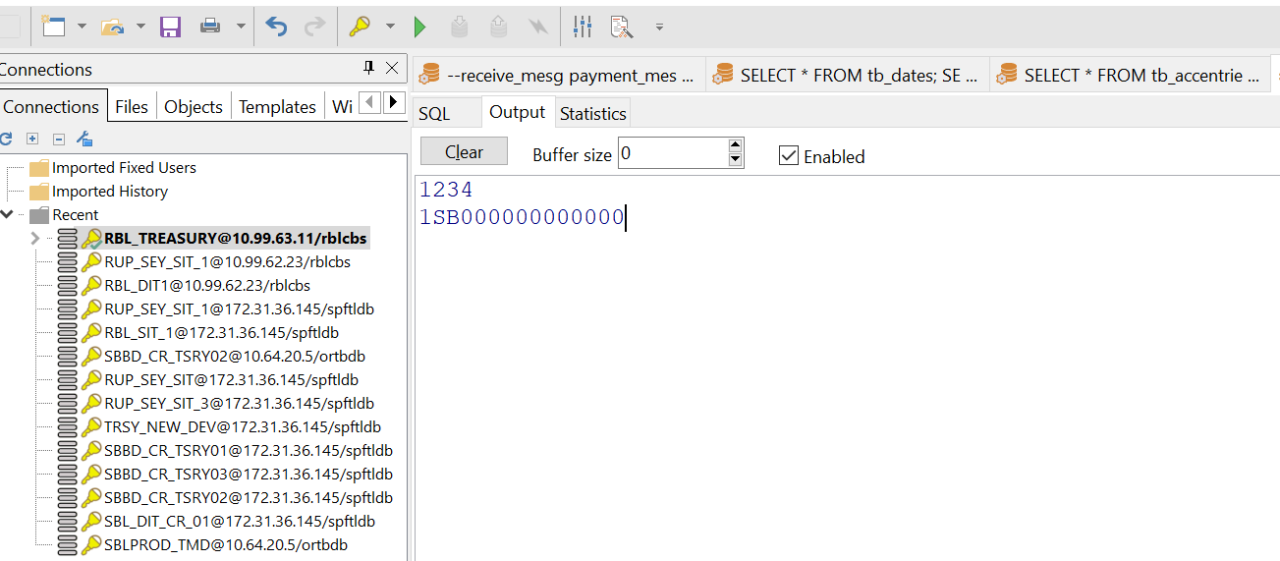

For example, if any deals got matured, first amount will appear and then reference number. Then run below SQL and update **ONLY** “**LCY_AMT**” column with that amount.

SELECT * FROM TB_ACCENTRIES A WHERE A.TRANSACT_REF_NUM='INPUT_REF_NUM_HERE' AND A.PROCESS_CODE='IN'

AND A.TRANSACT_TYPE='IN' AND A.POSTED='M' FOR UPDATE;

***Input reference number in 'INPUT_REF_NUM_HERE' part in the above query.

***Deals having multiple months inside tenor should treat manually. Please consult before doing this.

# Square off date in holiday

Run below query after EOD complete of a day.

SELECT * FROM TB_FX_SPECULATIVE_SQUARE_OFF ORDER BY SQUARE_OFF_DATE DESC;

Check “**SQUARE_OFF_ACC_GEN_DATE”.** If any date with “**ACC_GEN_FLG**” value **“N”** is in FRIDAY or any Global Holiday (means CBD will jump over the date while EOD/SOD will run), then update the date with immediate working date.

For example, 01-Apr-2022 is Friday, so from Thursday 31-Mar-2022 system will move directly on Saturday 2-Apr-2022. If any record has value 01-Apr-2022 in “**SQUARE_OFF_ACC_GEN_DATE”** column with “**ACC_GEN_FLG**” value **“N”**, then update the date to next working date as 2-Apr-2022.

# Delete deals

System has options from front end to delete a deal if the maturity date is greater than CBD. If any deals that matured today or earlier and has to be deleted by support (deals may be duplicate/wrong input etc.) then run below SQL with reference number.

## For FX deal.

UPDATE TB_FXBACKOFFICE B SET B.DEAL_STATUS=8,B.PURPOSE='BO REVERSAL/AUTH' WHERE B.REF_NUM IN ('INPUT_REF_NUM_HERE');

## For MM deal.

UPDATE TB_MMBACKOFFICE B SET B.DEAL_STATUS=8,B.PURPOSE='BO REVERSAL/AUTH' WHERE B.REF_NUM IN ('INPUT_REF_NUM_HERE');

***Input reference number in 'INPUT_REF_NUM_HERE' part in the above query.